A Perfect Pitch: Topspin vs Backspin

The World Series of Major League Baseball (MLB) is one of the most famous and viewed sporting invents in the world. Since the 1800’s it has been America's beloved national pastime with the game having such a simple objective; score more runs than your opponent. The idea is to hit the ball thrown at you as far as you can before running around 4 bases to complete a run. Yet, despite the games simplicity there are over a dozen different pitches and because of this our project will explore and compare two very diverse pitches; the fastball and curve ball. The question at hand has two parts, how does the effect of spin (topspin and backspin) effect the trajectory of the baseball while in the air. The second question would then undoubtedly be which of these two pitches are more formidable for the batter to hit. Our hypothesis was that the addition of backspin on a baseball pitch would cause the ball to curve, creating a curve ball, but not go far. On the other hand, we thought that the use of topspin on a baseball would cause the ball to travel straightforward in the air and go further in distance than a baseball with the effect of backspin. The reasoning is based on the analysis of the physics. We considered Newton's first law of motion which states an object at rest stays at rest and an object in motion stays in motion with the same speed and in the same direction unless acted upon by an unbalanced force. With that said, we speculated that an object with backspin would create a curveball and that a ball with backspin would remain in a backwards motion which would lead to the baseball having a short-lived air time. Meanwhile, for the topspin we assumed that this would lead to a fastball and having a spinning motion in the forward or top direction would cause the ball to remain in a forward or rising direction which would lead to the ball having ample air time over a ball experiencing backspin.

**Description of Model:**

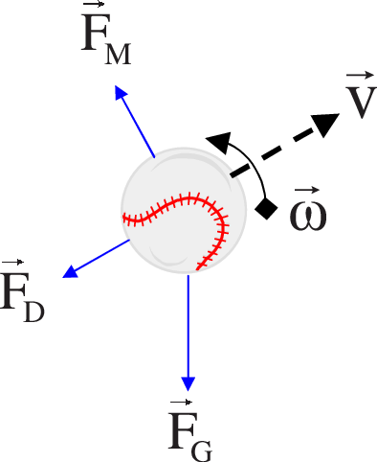

Link: <http://m2.askthephysicist.com/ask_phys_q&a_old8.html>

There are several key factors that need to be analyzed to model the baseballs flight trajectory. There are three main forces to consider: gravity(Fg), Magnus force (Fm) and Drag force (Fd). There formulas are as follows:

Fg= *(m × g)*

*Where m* is the mass of ball and *g*is gravitational acceleration (9.8m/s/s). The force of gravity is a constant force. This is important because it allows us to acquire a numerical understanding of how much the ball is being pulled downwards towards the ground no matter where the ball is located throughout its trajectory.

*Fm = S (w × v)*

*Or*

*Fm = 0.5ρACLv2*

Where w is the angular velocity vector of the object, *v is the* velocity of the fluid, and *S is the* air resistance coefficient across the surface of the object (Spin). The Magnus force is the epitome of Newton's third law, for every action, there is an equal and opposite reaction. The Magnus Force is the lift on a ball or spinning object moving through a fluid. Therefore, Fg causes the ball to rise in the positive y-direction while Fg is a force in the negative y-direction.

*Fd = 0.5 x C x ρ x A x V2*

Where A is the area of the ball, C is the drag coefficient (0.40), V is the velocity, m/s and   
ρ is the density of fluid, kg/m3. The Drag Force is perpendicular to the Magnus and can be seen as air friction or air resistance. Fd causes the slowing down of an object and is especially relevant in the x-direction (negative).

The only changing variable in these three formulas is velocity; linear and angular. By implementing the formula F = ma the acceleration can be easily calculated, where F is the summation of all the forces in a certain direction and m is the mass of the ball. We can then calculate linear and angular velocity respectively.

*vf =vi +a*Δt*

*w=v/r*

Where the initial velocity is in fact a preassigned, realistic value determined by professional baseball statistics. The value “v” is the linear Velocity and “r” is the radius of ball. The linear velocity is opposite to the Drag force and is there for a major contributor in the x-direction (positive) and angular velocity is the rate of change of angular position of a rotating object. Lastly, all there’s left is to calculate the position of the ball in the X and Y direction at each point throughout the balls flight.

*xf=xi + vxi * dt*

*yf=yi + vyi *dt*

**Description of Computational Method**

In the first phase, Euler’s method is used to initialize the position and velocity of the baseball. This method made it possible to solve first order first degree differential equation. The importance of this method is that it serves as the basis to construct more complex methods, with just a given initial value. Most of the initial values as stated earlier have been preassigned by us therefore Euler’s method gave us the building blocks to start our code at the first iteration. So, Euler’s method made it possible to calculate the ball the moment it left the pitcher’s hand.

In the second phase, Verlet’s method was used. This method was used to calculate the trajectory beyond the initial pitch. It made it simple and attainable to integrate Newton's equations of motion. It made it possible to calculate, for each increment of time, the acceleration through Newton’s laws (F=ma). From this, the new velocity and position of the baseball can then be determined using kinematic equations. The X and Y components of acceleration are calculated according to the forces acting on the ball (force due to gravity, drag, and lift). The drag and lift force are both calculated as magnitudes and then as stated earlier, applied in the proper direction (drag being opposite direction to velocity and lift force being perpendicular to velocity). Since, each of these two forces is dependent on-air density, area of object and velocity then the following formula can be made:

*Fx = 0.5*A*P * (Vx2 . + Vy2  )1/2 * (Cd vx + CL vy )*

*Fy= 0.5*A*P * (Vx2 . + Vy2  )1/2 * (**CL vx - Cd vy )  - mg*

Where the equations are set for a ball experiencing backspin. If the ball has topspin, the sign in front of CL must be changed in each of these equations.

After force and acceleration are calculated, the x and y components of both the velocity and position are then updated using simple kinematic formulas. Time is then incremented in a Verlet loop where time iterates until the ball reaches a height of zero which therefore means it has reached the ground and so the ball’s trajectory is complete.

**Results**

After plotting both pitch trajectories; back spin pitch and top spin pitch, we obtain the following. It can clearly be seen that the back-spin pitch, that is mostly used in fastballs to avoid the downward curve of the ball, has more of a linear trajectory as compared to the top spin pitch. This is so since the top spin pitch, as seen from our graph below, has more of a curved trajectory. The top spin pitch is mostly used in curveballs since it makes the ball dip downwards which makes it more challenging for the batter. Our graphs seem to generate a lot of lift in our pitches which is not a real-life situation. The reason why this was down was to clearly point out the trajectory of each type of pitch.

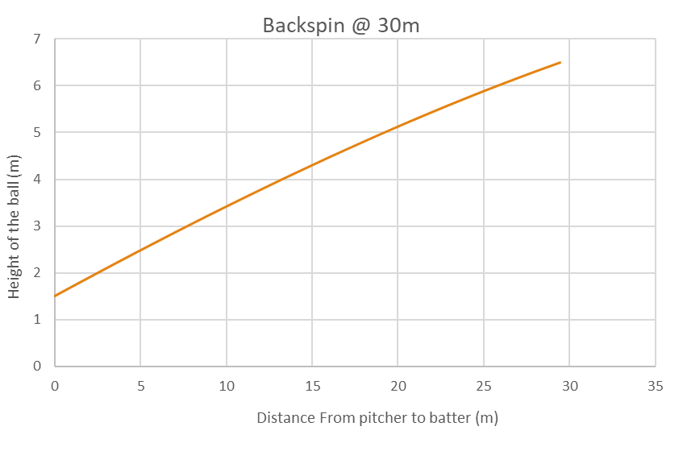

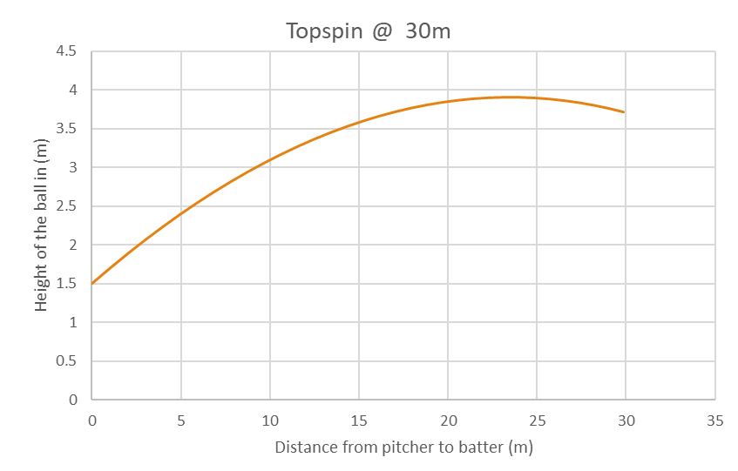

The graph below demonstrates how the fastball pitch looks like compared to the vertical and horizontal distances to the home plate. This graph also puts the curveball into perspective. These pitches were thrown by a professional MLB player named Ted Lilly.

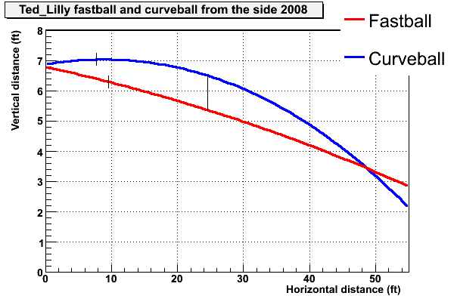

It can clearly be seen how the blue curve resembles the curve we obtained from our graph depicting top spin pitch trajectory. This blue curve is the trajectory of a ball thrown with topspin (a curveball). It can also be seen how the red, almost linear line, resembles our back-spin pitch curve. The red line depicts a fastball which utilizes topspin. By seeing how we got near identical results, we can compare our data.

Link: <https://tht.fangraphs.com/pitch-sequence-high-fastball-then-curveball/>

There is also a comparison to be made with the final trajectory of our simulation and that of realistic values.

+-----------+--------+-------+-------+------+

| PitchType | NP | speed | horiz | vert |

+-----------+--------+-------+-------+------+

| FB | 164816 | 91 | -6.2 | 8.9 |

| SL | 48190 | 84 | 0.7 | 3.7 |

| CB | 34274 | 77 | 5.2 | -3.3 |

| CU | 30831 | 82 | -7.4 | 6.0 |

+-----------+--------+-------+-------+------+

Link: <https://tht.fangraphs.com/fastball-slider-changeup-curveball-an-analysis/>

The results of our simulation show that the maximum height of a fastball (backspin) is 8.50m and that of a curveball (topspin) is 3.91m. Though the results are not identical, if we take the final results of the above chart where it says “vert” we can clearly notice that the highest vertical the fastball(FB) attains is 8.9m meanwhile the highest vertical the curveball (CB) reaches is 6.0m. Therefore, the results are similar enough that the following proclamation can be made, a fastball (backspin) goes much further and higher than a curveball (topspin) due to the spins upward motion in the air during a backspin and the opposite is true during a topspin.

|  |
| --- |
|  |
|  |

**Human Reaction**

A fastball (backspin pitch), from a professional pitcher (90 miles per hour), will only take 400 thousandths of a second to reach home plate. When the pitcher throws the baseball towards the plate, the batter must decide to swing when the ball is mid-point towards the plate. This is approximately about 25-30 feet from home plate. This is so since at that point, the ball will arrive 250 thousandths of a second later; this is the average human reaction time. The batter must not only decide where he should swing, but he must also decide whether he shouldn’t swing at all if the ball is not in the proper zone. Hitting the ball, a little too high or a little too low will result either in a foul ball or a ground ball.

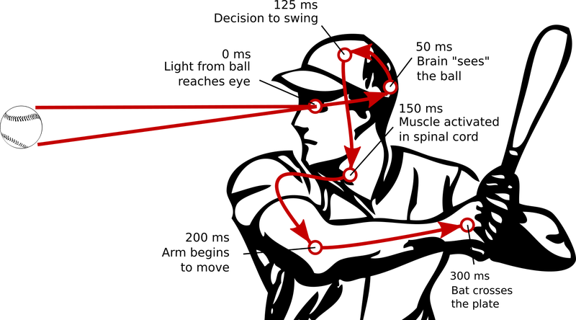

Even though curveballs are generally thrown slower than fastballs, they have their own qualities. Compared to a fastball, a curveball varies around 15-20 degrees more in vertical and horizontal movement. This makes it therefore harder to hit since when the ball is halfway towards home plate, the batter basically has to guess which way the ball will dip and curve. The longer trajectory of the curveball towards the home plate accounts for its variation of degrees.

**Discussion**

The results that we have obtained from our graphs show almost identical curves compared to an actual MLB pitcher’s graph. We do have different altitudes in which the pitch reaches however, the trajectories to get there are identical. In the MLB, the fastball is the most commonly used pitch.

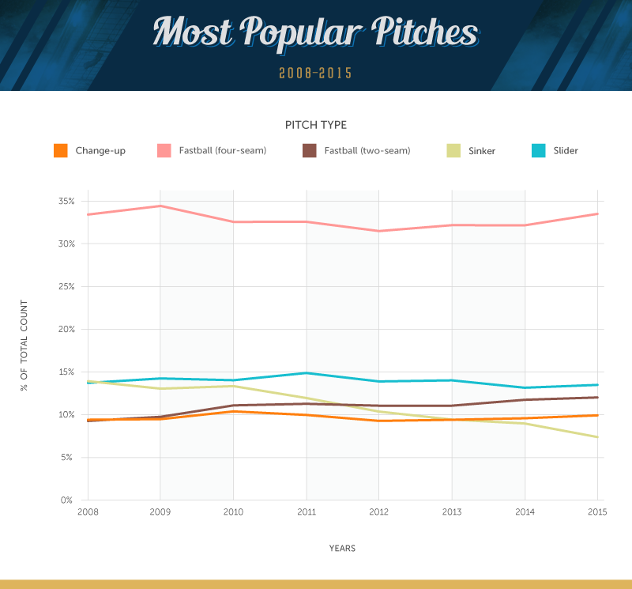

Link: <http://content.fanatics.com/mapping-all-major-league-baseball-pitches/>

We have examined and compared our graphs to that of the one above. We have concluded that throwing a fastball is the most effective pitch for the pitcher to throw since it is the most reliable and easiest to control. Since, it has a relatively straight trajectory the pitcher can have confidence in knowing how the ball will react when it leaves it hands. However, the curveball is perfect for confusing the batter. The curveball is harder to throw but has a great outcome when done properly.

+------+------+------+------+------+

| Cnt | FB% | SL% | CB% | CU% |

+------+------+------+------+------+

| 3-0 | 0.84 | 0.05 | 0.03 | 0.08 |

| 3-1 | 0.80 | 0.10 | 0.03 | 0.07 |

| 2-0 | 0.75 | 0.11 | 0.04 | 0.10 |

| 3-2 | 0.66 | 0.17 | 0.08 | 0.09 |

| 1-0 | 0.63 | 0.15 | 0.08 | 0.13 |

| 2-1 | 0.64 | 0.16 | 0.08 | 0.13 |

| 0-0 | 0.63 | 0.15 | 0.12 | 0.09 |

| 1-1 | 0.53 | 0.19 | 0.13 | 0.14 |

| 0-1 | 0.52 | 0.20 | 0.15 | 0.12 |

| 2-2 | 0.51 | 0.21 | 0.16 | 0.12 |

| 1-2 | 0.48 | 0.22 | 0.19 | 0.11 |

| 0-2 | 0.51 | 0.21 | 0.18 | 0.09 |

+------+------+------+------+------+

Link: <https://tht.fangraphs.com/fastball-slider-changeup-curveball-an-analysis/>

This table shows how advantageous the count is for the hitter, 3-0 being the best hitter’s count and 0-2 being the worst, compared to which pitch is being used depending on the situation. If we look at the fastball percentage: there is an impressive (84% on 3-0) which quickly falls to about 50% fastballs on the worst hitter’s counts. This table is showing that when behind in the count pitchers will try to throw a strike to move the count in their favor. Since, the fastball is the easiest pitch to control, that’s the pitch they choose. But, when they are ahead in the count, the pressure is reduced dramatically, so they can try the fancy stuff, for instance curveballs.

If the pitchers had more confidence and truly wanted to disorient a batter’s perspective of a pitch then the curveball would be the more ideal pitch. Especially, when considering the reaction time of a human is challenged more when he/she tries to hit a curveball which makes it harder to hit.

References

https://tht.fangraphs.com/pitch-sequence-high-fastball-then-curveball/

<https://backyardbrains.com/experiments/reactiontime>

Book by Nicholas Giordano: College Physics: Reasoning and Relationships

<http://m2.askthephysicist.com/ask_phys_q&a_old8.html>

<https://tht.fangraphs.com/fastball-slider-changeup-curveball-an-analysis/>

<http://content.fanatics.com/mapping-all-major-league-baseball-pitches/>